CMPSC 462 – Assignment-2 (30 points)

Due date: 9/2/2022

Note: attach screenshots of your program and results under each programming exercises. Please make sure that the screenshot is readable. Don’t attach a very small screenshot image.

- Create a Python program that asks the user to enter two sets of comma-separated values. Use the string split() method to parse the line and then use the set() function to covert the lists to sets. Demonstrate set theory for the two sets by displaying the two sets and their relationship to each other as subset, superset, union, intersection, and difference. 10 points
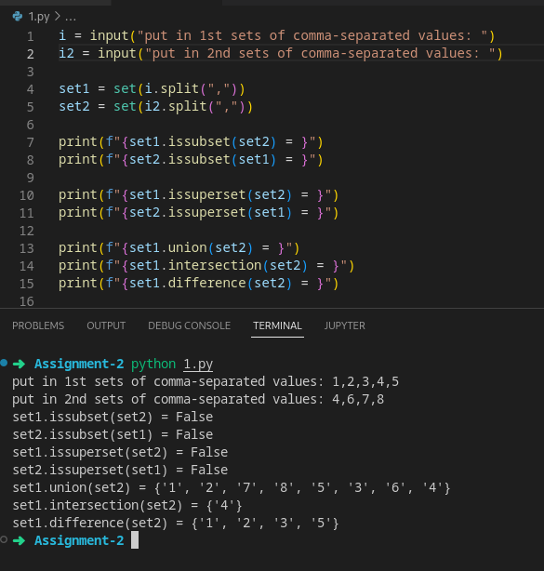

- How can the last element of a set be deleted? Justify your answer? 5 points

it is possible with a workaround, that is having another variable with the value of the ‘last’ element, assuming the set are created from some kind of other value.

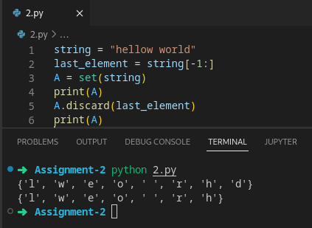

Otherwise it is not possible as sets can’t be referred by index.

- Answer the following? 5 points

- Is a set a subset of itself? Explain?

Yes because a subset contain all or some of the other set, and a set contains all of itself therefore it is a subset of itself.

What happens if you pass a dictionary to a set constructor? for example: set(dictionary1). Explain?

The keys of the dictionary will be turn into values of the set and the value of the dictionary will be discarded, when you loop through a dictionary using a for each loop, only the dictionary key are returned so when turning the dictionary into a set, only the keys are available to be converted into a set.

- What are the differences between a set and a frozen set? Show how you can create a frozen set? 5 points
a frozen set is like a set but you can’t mutate it (ie: using functions like add(), remove())
to create a frozen set you need to use frozenset()

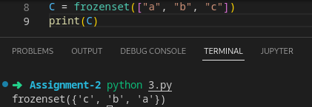

- Write a Python program to check if two given sets have elements in common, remove those elements and return the set with unique elements? 5 points

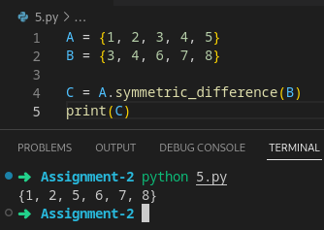

Deliverables:
- This assignment word file - program and Outputs with appropriate screenshots

